**Polynomial Regression (Simple & Multiple)**

**Explanations:**

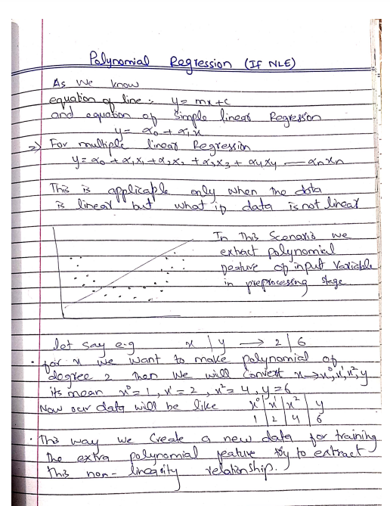

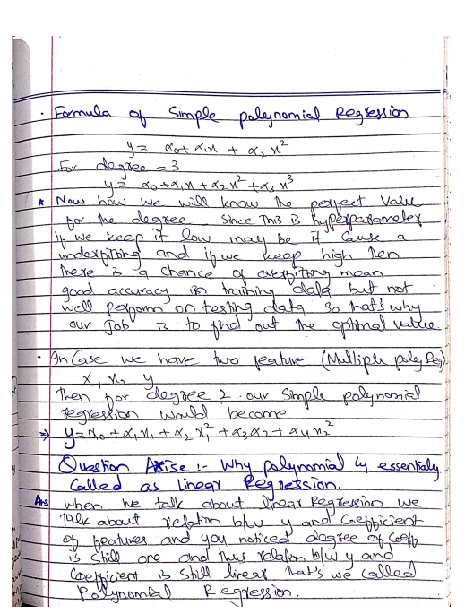

**Difference Between Linear Regression & Polynomial Regression**

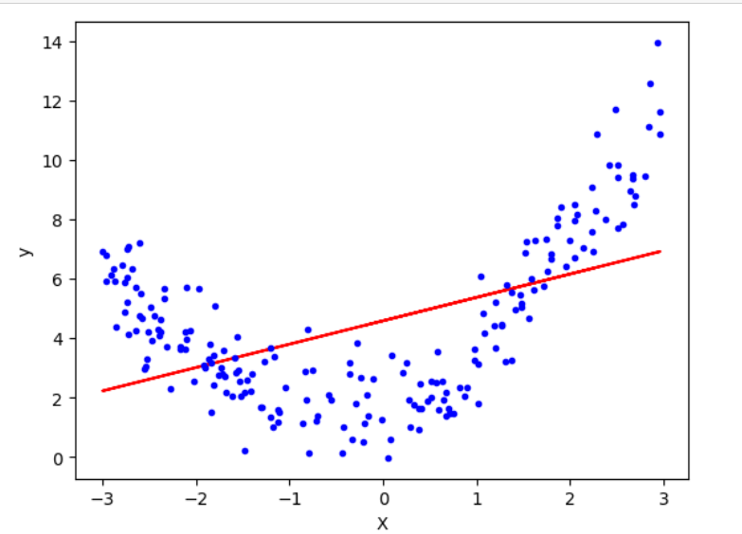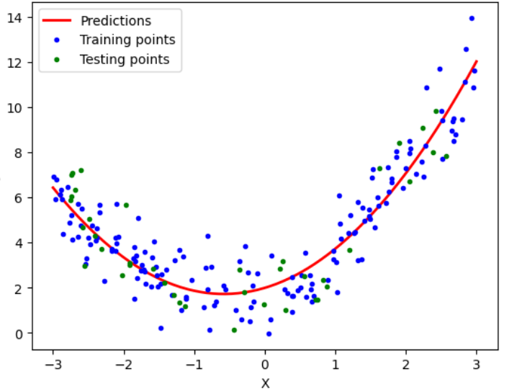

**Code:**

import numpy as np

import matplotlib.pyplot as plt

from sklearn.model_selection import train_test_split

from sklearn.linear_model import LinearRegression,SGDRegressor

from sklearn.preprocessing import PolynomialFeatures,StandardScaler

from sklearn.metrics import r2_score

from sklearn.pipeline import Pipeline

X = 6 * np.random.rand(200, 1) - 3

y = 0.8 * X**2 + 0.9 * X + 2 + np.random.randn(200, 1)

# y = 0.8x^2 + 0.9x + 2

plt.plot(X, y,'b.')

plt.xlabel("X")

plt.ylabel("y")

plt.show()

# Train test split

X_train,X_test,y_train,y_test = train_test_split(X,y,test_size=0.2,random_state=2)

# Applying linear regression

lr = LinearRegression()

lr.fit(X_train,y_train)

y_pred = lr.predict(X_test)

r2_score(y_test,y_pred)

plt.plot(X_train,lr.predict(X_train),color='r')

plt.plot(X, y, "b.")

plt.xlabel("X")

plt.ylabel("y")

plt.show()

# Applying Polynomial Linear Regression

# degree 2

poly = PolynomialFeatures(degree=2,include_bias=True)

X_train_trans = poly.fit_transform(X_train)

X_test_trans = poly.transform(X_test)

print(X_train[0])

print(X_train_trans[0])

lr = LinearRegression()

lr.fit(X_train_trans,y_train)

y_pred = lr.predict(X_test_trans)

r2_score(y_test,y_pred)

print(lr.coef_)

print(lr.intercept_)

X_new=np.linspace(-3, 3, 200).reshape(200, 1)

X_new_poly = poly.transform(X_new)

y_new = lr.predict(X_new_poly)

plt.plot(X_new, y_new, "r-", linewidth=2, label="Predictions")

plt.plot(X_train, y_train, "b.",label='Training points')

plt.plot(X_test, y_test, "g.",label='Testing points')

plt.xlabel("X")

plt.ylabel("y")

plt.legend()

plt.show()

def Apna_Polynomial(degree):

X_new=np.linspace(-3, 3, 100).reshape(100, 1)

X_new_poly = poly.transform(X_new)

polybig_features = PolynomialFeatures(degree=degree, include_bias=False)

std_scaler = StandardScaler()

lin_reg = LinearRegression()

Apna_Polynomial = Pipeline([

("poly_features", polybig_features),

("std_scaler", std_scaler),

("lin_reg", lin_reg),

])

Apna_Polynomial.fit(X, y)

y_newbig = Apna_Polynomial.predict(X_new)

plt.plot(X_new, y_newbig,'r', label="Degree " + str(degree), linewidth=2)

plt.plot(X_train, y_train, "b.", linewidth=3)

plt.plot(X_test, y_test, "g.", linewidth=3)

plt.legend(loc="upper left")

plt.xlabel("X")

plt.ylabel("y")

plt.axis([-3, 3, 0, 10])

plt.show()

Apna_Polynomial(350)

# 3D polynomial regression

x = 7 * np.random.rand(100, 1) - 2.8

y = 7 * np.random.rand(100, 1) - 2.8

z = x**2 + y**2 + 0.2*x + 0.2*y + 0.1*x*y +2 + np.random.randn(100, 1)

# z = x^2 + y^2 + 0.2x + 0.2y + 0.1xy + 2

import plotly.express as px

df = px.data.iris()

fig = px.scatter_3d(df, x=x.ravel(), y=y.ravel(), z=z.ravel())

fig.show()

lr = LinearRegression()

lr.fit(np.array([x,y]).reshape(100,2),z)

x_input = np.linspace(x.min(), x.max(), 10)

y_input = np.linspace(y.min(), y.max(), 10)

xGrid, yGrid = np.meshgrid(x_input,y_input)

final = np.vstack((xGrid.ravel().reshape(1,100),yGrid.ravel().reshape(1,100))).T

z_final = lr.predict(final).reshape(10,10)

import plotly.graph_objects as go

fig = px.scatter_3d(df, x=x.ravel(), y=y.ravel(), z=z.ravel())

fig.add_trace(go.Surface(x = x_input, y = y_input, z =z_final ))

fig.show()

X_multi = np.array([x,y]).reshape(100,2)

X_multi.shape

poly = PolynomialFeatures(degree=30)

X_multi_trans = poly.fit_transform(X_multi)

print("Input",poly.n_features_in_)

print("Ouput",poly.n_output_features_)

print("Powers\n",poly.powers_)

X_multi_trans.shape

lr = LinearRegression()

lr.fit(X_multi_trans,z)

X_test_multi = poly.transform(final)

z_final = lr.predict(X_multi_trans).reshape(10,10)

fig = px.scatter_3d(x=x.ravel(), y=y.ravel(), z=z.ravel())

fig.add_trace(go.Surface(x = x_input, y = y_input, z =z_final))

fig.update_layout(scene = dict(zaxis = dict(range=[0,35])))

fig.show()

**Screenshot:**



